**Pirate Ship --- Line Tracking**

After completing the basic functions, we’re now ready to give our robot an upgrade: black and white transmission capabilities. Transmission capabilities are among a robot’s most fundamental capabilities. The robot car is able to move along a pre-configured track or path through self-initiated movement. We’ll be using the line tracking sensor: using this helps the robot recognize and differentiate between the black and white lines, which in turn completes black/white transmission.

**Hardware Parts**

* Line Tracking Sensor × 3

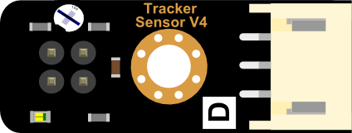

* Width 2.5CM Black Electrical Tape × 1

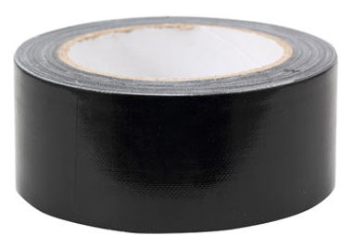

* 1M*1M White Board × 1



* M3*30MM Nylon support (screws, nuts) × 3

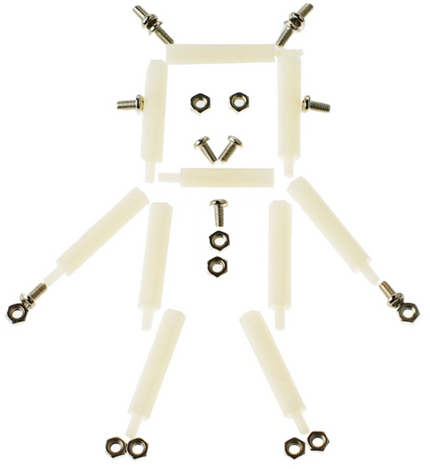

**Assembly Instructions**

After finding the necessary parts, you’re ready to start assembling. Assembly won’t be too difficult – just follow the following directions and you’ll have no problems.

**Step 1: Sort out and arrange materials**

Find the components for the 3 sensors that need to be assembled. In addition, find the 3 nylon supports and their accompanying screws and nuts.

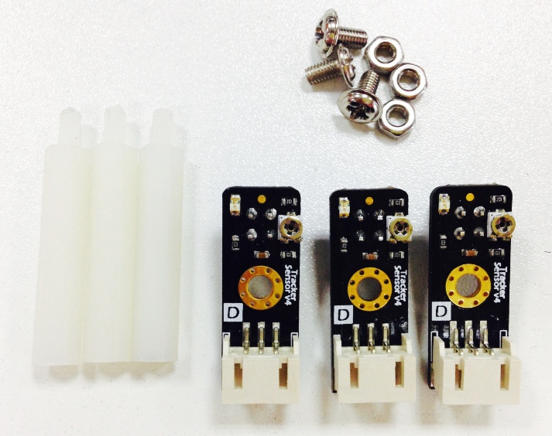

**Step 2: Attaching the Nylon supports**

Using nuts, attach the nylon supports on top of the Mini sensors. When attaching the supports, please pay attention to their direction: the nuts and probes should both be in one direction.

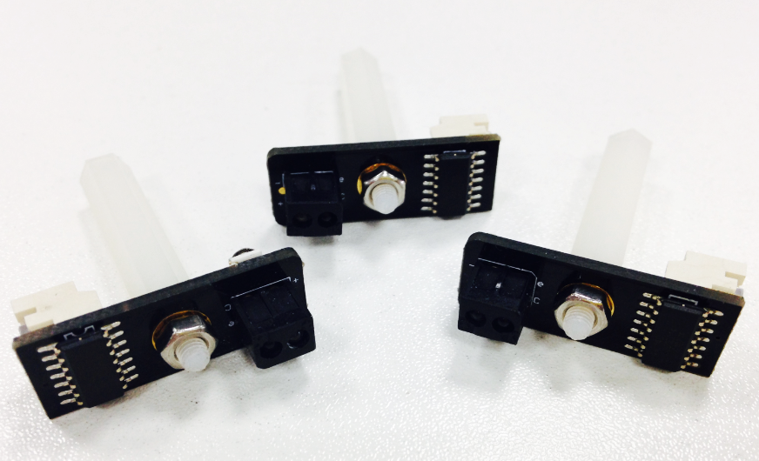

**Step 3: Assembling the sensor board**

Remove the upper plate from the Pirate. Then, attach the sensor board to the front of the Pirate.

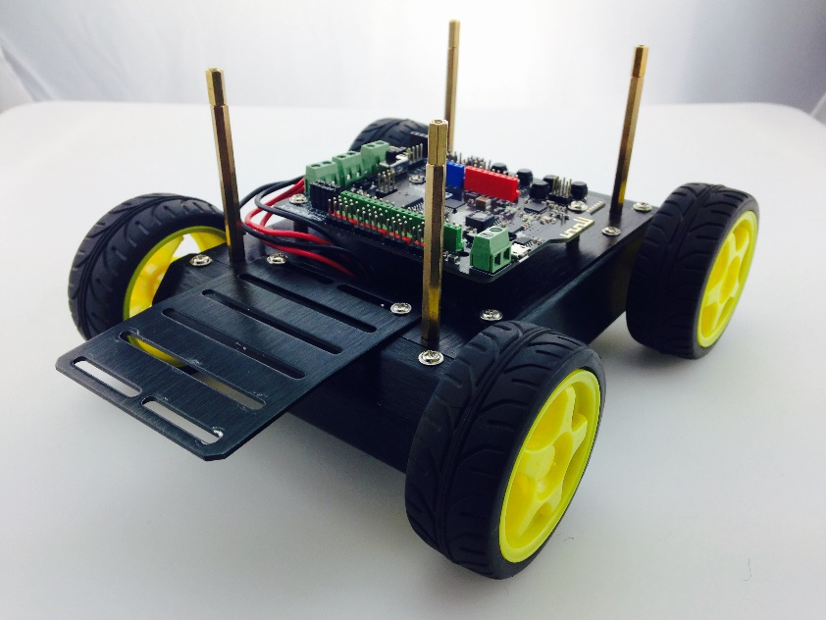

**Step 4: Assembling the transmission sensor**

First, connect the sensor with the wire designated for data transmission. Then, use your M3 screws to affix the sensors to the expansion board protruding from the front of the Pirate.

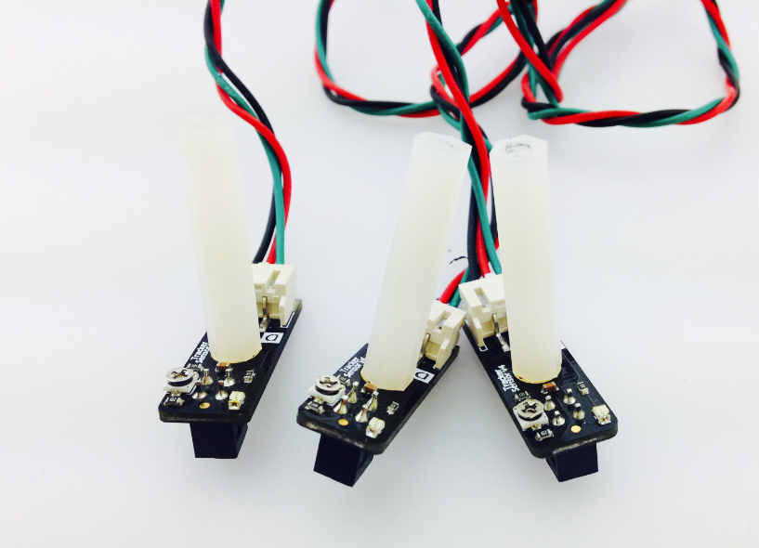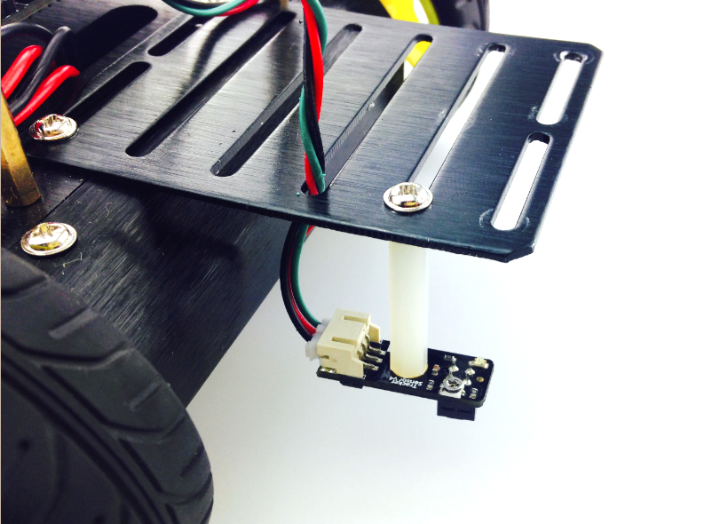

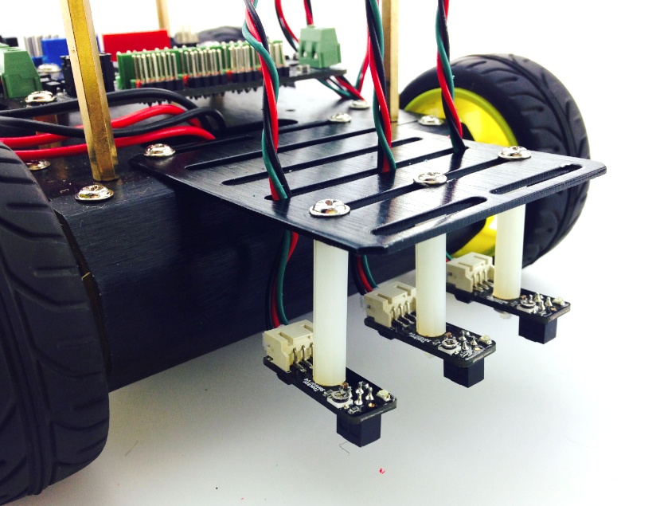

**Connecting the hardware**

After assembling the sensors, don’t rush to put the Pirate’s upper plate back on – before doing that, we need to first connect the sensors with the Romeo BLE control plate.

The picture on the left-hand side shows the correct ABC placement of the sensors on the sensor board, which corresponds to pins 10, 9, and 8 on the Romeo BLE board. When connecting the sensors, be sure to check that you’ve connected them in the proper sequence. After connecting the sensors, re-attach the Pirate’s upper plate back atop the base.

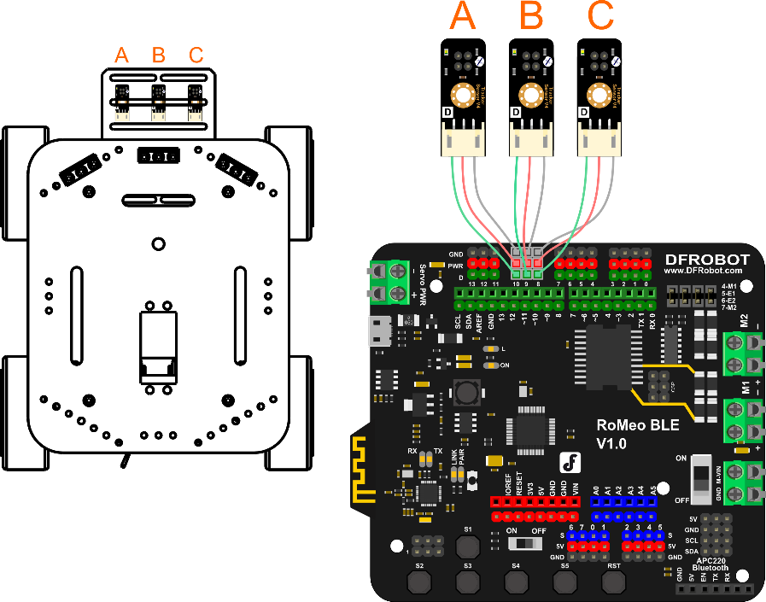

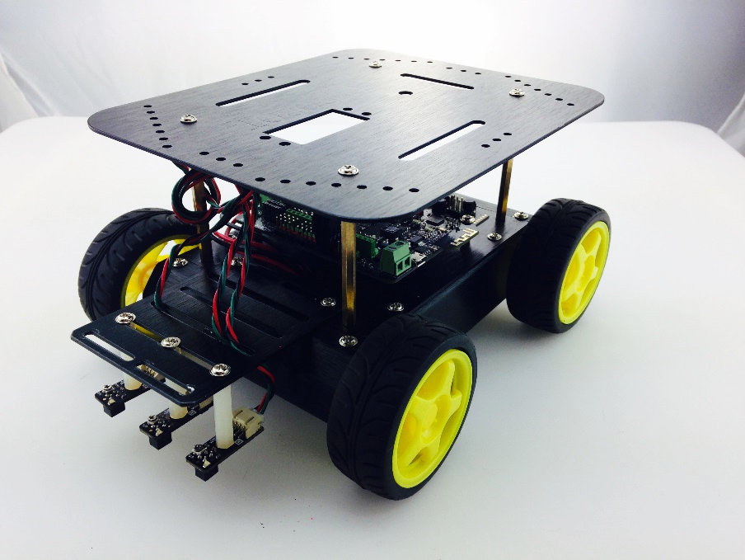

**Adjusting the sensors**

Before downloading code, we need to adjust our sensors. First, plug a USB cable into your BLE controller to give it power. As seen in the below picture, the sensor below has a Philips screw head; this screw head can be used to adjust the sensor’s detection of distance. Take a **white piece of paper** and place it beneath the sensor’s probe (the color of the paper is used for calibration purposes). Get a screwdriver and use it to tighten the Philips screw head. You’ll feel the sensor’s probe physically move up and down depending on how tightly you tighten the screw head. You’ll also see the sensor’s LED light up as soon as you start tightening. Tighten the screw head until the probe point is around 2 cm above the piece of paper.

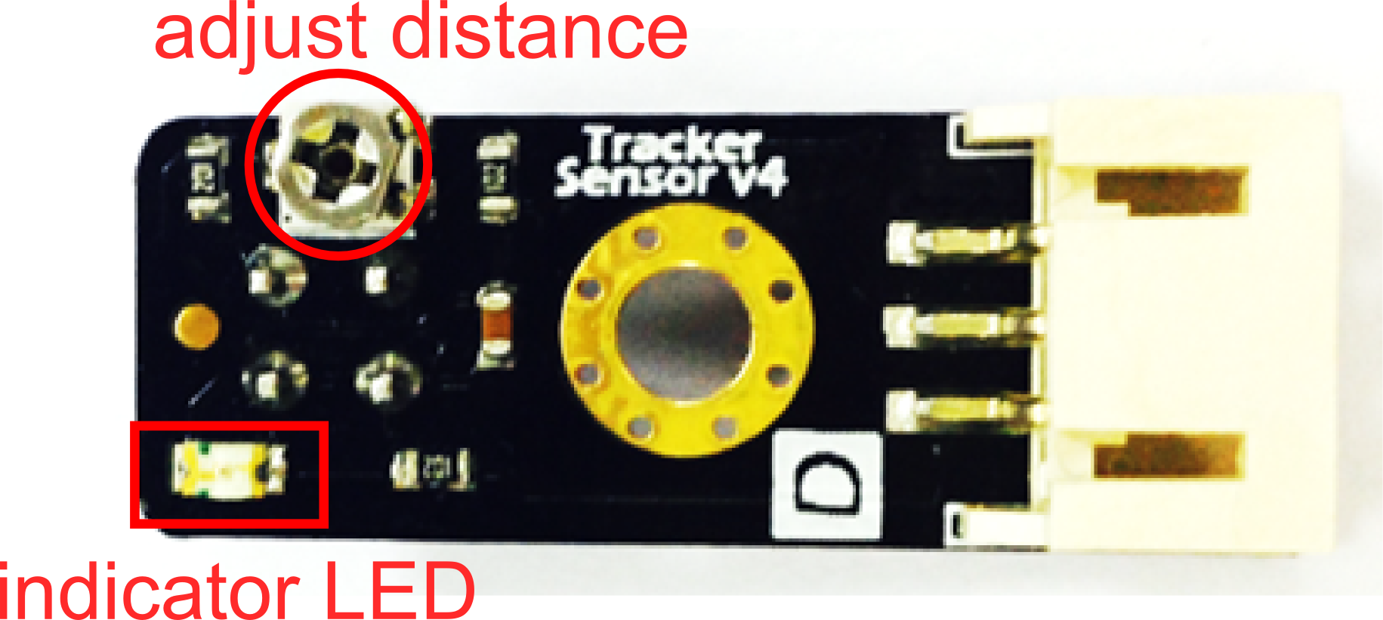

**Coding**

Plug in your USB. Download the Arduino code, named “HuntingLineBlack.ino”, from GitHub. Click the Upload button in the Arduino IDE to upload the code to your BLE control board.

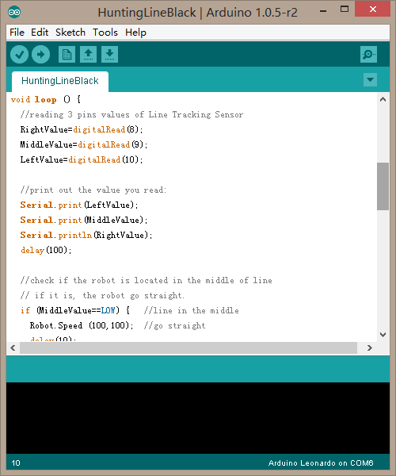

**Configuring your Pirate’s path**

Take out your whiteboard. Use your 2.5 cm wide electrical tape to lay out a path on the whiteboard as shown in the below picture.



The width of the wire is roughly 2.5 cm, the approximate distance between sensors A and C. We’ve chosen the path above for reasons relating to code; a later section will explain this reasoning more thoroughly.

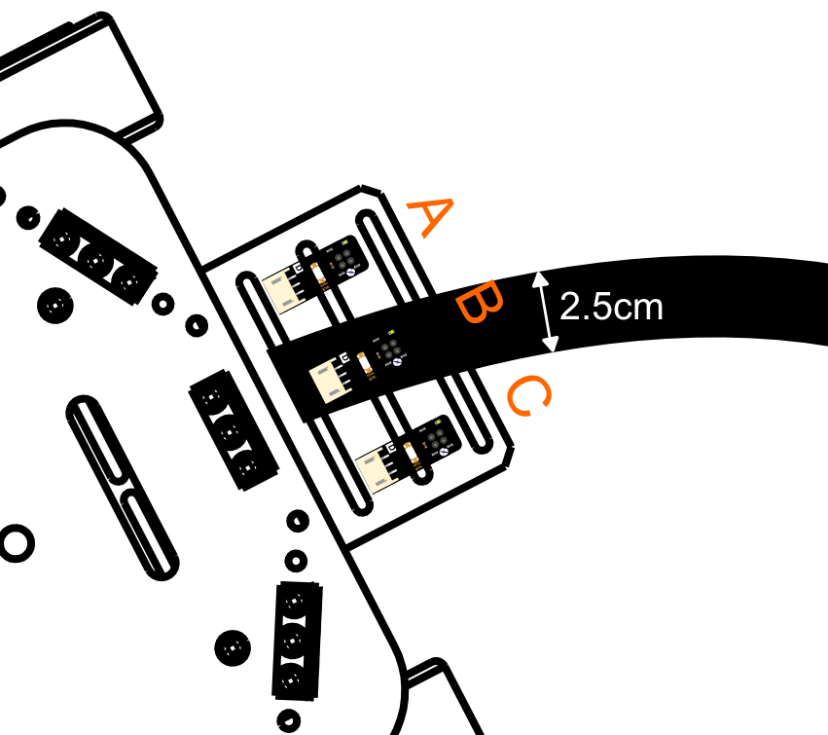

**Transmission: How it works**

How do we make our Pirate stay on its track? We need to ensure that the Pirate is consistently located in the middle of the track. The Pirate uses its 3 transmission sensors to calibrate its position relative to the track -- once it veers to the side, the Pirate will self-adjust back towards the middle.

When Our Pirate moves, three conditions will happen.

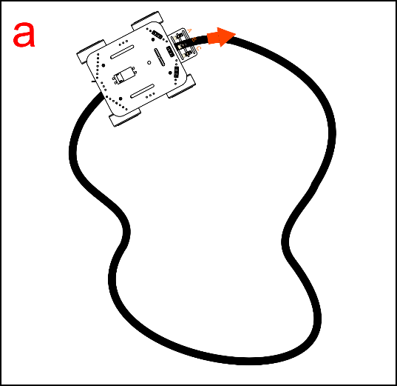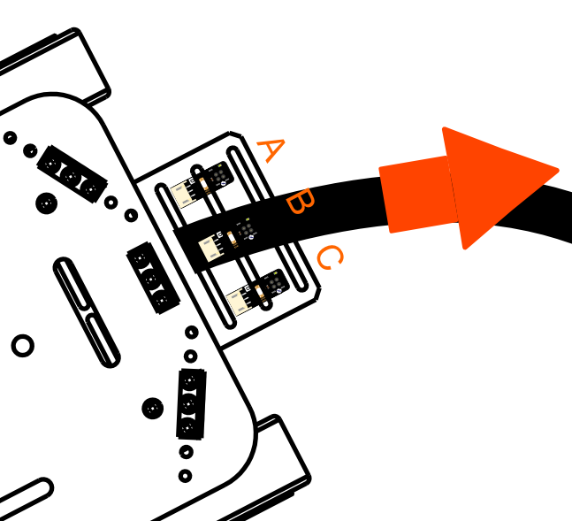

1. When the Pirate first begins moving along the track, only the middle sensor (B) detects the black line – the left and right sensors have not come into play yet. The car will remain centered along the track and move forward.

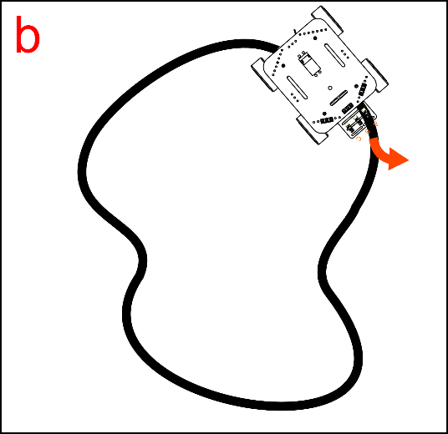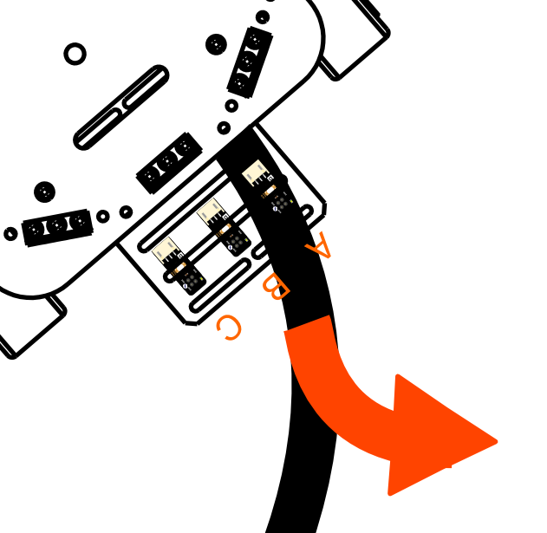

1. After continuing on its track, the Pirate might start to veer off center. Under these circumstances, the left and right sensors will try to detect the black line and self-guide the Pirate back towards the track. For instance, if the Pirate veers towards the right side of the track, the car will need to re-center itself by turning towards the left – the left sensor will kick in and automatically turn the car until it re-centers.

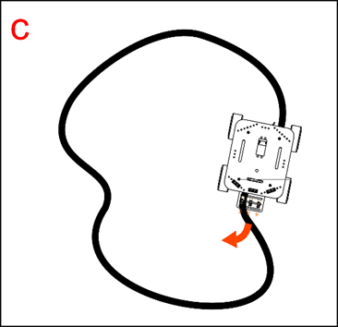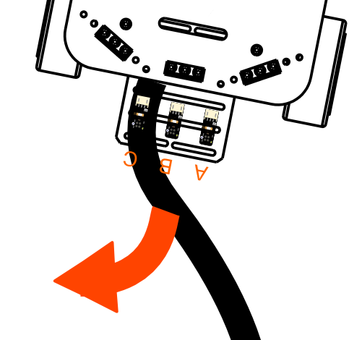

1. Conversely, if the Pirate veers towards the left side of the track, the right sensor will kick in and adjust the car’s path until it re-centers.

**Code Synopsis**

There’s no need to discuss the basic code – let’s just take a look at the part involving transmission.

int RightValue; //Right line tractor sensor on Pin 8

int MiddleValue; //Middle line tractor sensor on Pin 9

int LeftValue; //Left line tractor sensor on Pin 10

//reading 3 pins values of Line Tracking Sensor

RightValue=digitalRead(8);

MiddleValue=digitalRead(9);

LeftValue=digitalRead(10);

Use three variables – RightValue, MiddleValue, LeftValue – to record the 3 sensors’ read values.

The digitalRead(pin) function is used to read the digital Input/Output port value. If this part is still unclear, please check out our Terminology Manual or the Arduino website.

**When the middle transmission sensor detects a black line (the track), it’ll produce a LOW energy output. When they detect a white space, they’ll produce a HIGH energy output.**

Example A below illustrates the transmission code’s working principles. When the middle sensor detects a black line (the track), it’ll produce a LOW energy output. When the left/right sensors detect white space, they’ll produce a HIGH output.

if (MiddleValue==LOW) { //line in the middle

Robot.Speed (100,100);

delay(10);

}

else if ((LeftValue==HIGH) && (RightValue==HIGH)) {

Robot.Speed (100,100);

delay(10);

}

If the sensors detect the black line/track to the left while also detecting white space to the right, the Pirate will turn left. See Example B below:

else if ((LeftValue==LOW)&&(RightValue==HIGH)){

Robot.Speed (-100,100); //turn left

delay(10);

}

Conversely, if the sensors detect the black line/track to the right while also detecting white space to the left, the Pirate will turn right. See Example C below:

else if ((LeftValue==HIGH)&&(RightValue==LOW)){

Robot.Speed (100,-100); //turn right

delay(10);

}

**Considerations**

Wouldn’t you say that robots aren’t as hard to assemble as you might’ve thought? After upgrading your transmission, you can make your Pirate pretty much “fall-proof” – if you live in a two-floor house, for instance, your car won’t flip over helplessly the moment it encounters stairs. In this sense, transmission is a basic, useful function in building robots.